INSTALLATIION GUIDE

for the

Web-based Course Registration System

INSTALLATIION GUIDE

for the
Web-based Course Registration System

Contract No
16

Prepared For:
International College
University of Science and Technology, Yemen

Prepared By:
Asem Mohammed Abdulaziz Farhan

Authenticate by __________________ Approved by __________________
(Contracting agency) (Contractor)

Date __________________________ Date _______________________

1 INTRODUCTION

1.1 Identification

System Number : IC-Y2010-S07-C16
System Name : Web-based course registration system
System Abbreviation : W_CRS

Overview of the Documents

This Installation Guide is used for guiding the users of the system how to use the Web-based course registration system properly.

- INSTALLATION

The software that is needed for the system to work is Wamp package which contain MYSQL, PHP and Apachi server. These programs work as an environment to enable the system to work smoothly and without errors. This software is in the same CD of the system

Installation Guide:

To install the W_base Course Registration System do the following:
- Install the Wamp package.
- Follow the wizard to guide you through the installation.
- Let the username be "root" and set the password.
- Open the MYSQL database management system.
- Create database and name it as CRS.
- Import the system database “CRS.SQL” from (Database SQL) folder in the CD to MYSQL DBMS.
- Copy the W_CRS folder from (System) folder in the CD to the www folder located in the Wamp folder (for example C:\wamp\www\).
- Open your web browser, for example Microsoft explorer, and type the name of the server followed by the main page of the system (for example localhost/ W_CRS/index.php)
- The index (the login) page will appear, refer to Figure 1.
- Enter a valid user name and password.
- Now the system can be used.

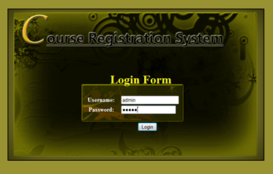
Figure 1: index page

NOTE: All the above mentioned programs are included within the CD provided with the System and the full documentation.

